CloudBurst DeltaLake


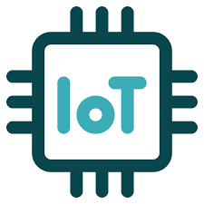

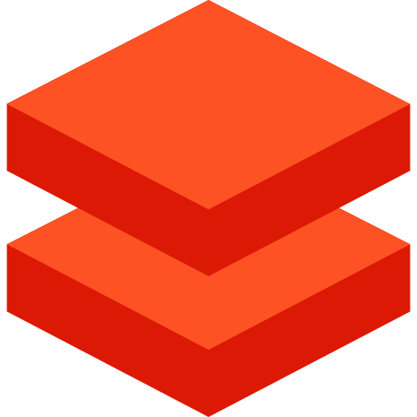

Nuwan Keshara Galappaththi
Data Engineer

Contents
Project Overview 3
1. Project Description 3
2. Project Purpose 3
3. Project Objectives 3
4. Project Architecture 4
Technology Stack: 4
Project Flow: 5
Technical Documentation 6
1. Data Sources 6
2. Data Ingestion 8
i) Azure IoT Hub 9
ii) Azure Event Hub 10
3. Data Transformation 13
i) Azure Databricks 13
ii) Code explanation 15
4. Data Visualization 18
5. Version Control 19
i) Azure DevOps 19
References 20

Project Overview

Project Description
- This project focuses on building a data pipeline to ingest and process IoT weather data, storing it in an Azure Databricks data Lakehouse using the Delta format and the Medallion Architecture. Power BI used used to visualize the data for analysis.

Project Purpose
- Develop knowledge in Azure Databricks, Azure DevOps, Data Lake and IoT streaming tools and technologies.
- Improve knowledge in data concepts and tools.
- Demonstrate my interest and enthusiasm for data engineering.

Project Objectives

- Data Collection: Collect weather data from IoT devices over a defined time interval by reading sensor outputs.

- Data Ingestion: Establish a network connection to transmit real time IoT weather data for processing.

- Data Processing/Transformation: Implement data cleansing, integration, transformation and aggregation processes to convert raw data into meaningful information.

- Data Storage: Design and implement a data Lakehouse on Azure Databricks utilising Delta format and the Medallion Architecture (Bronze, Silver, Gold) for weather data storage layer.

- Data Visualization: Develop insightful reports and visualizations from the cleansed data using Power BI.

- Version Control: Implement a Continuous Integration (CI) pipeline using Azure DevOps and Databricks for version control

Project Architecture

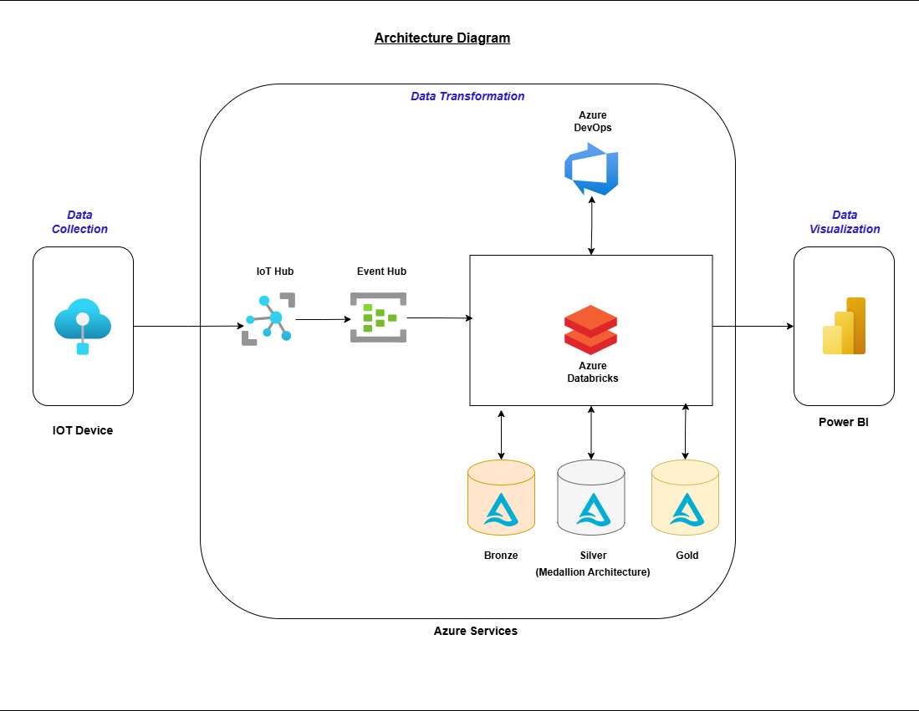

Technology Stack:
- Azure IoT Hub
- Azure Event Hub
- Azure Databricks (Delta Lake, PySpark, Python)
- Azure Data Lake Storage Gen2 (ADLS Gen2)
- Azure DevOps
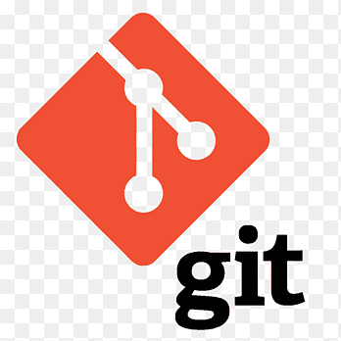
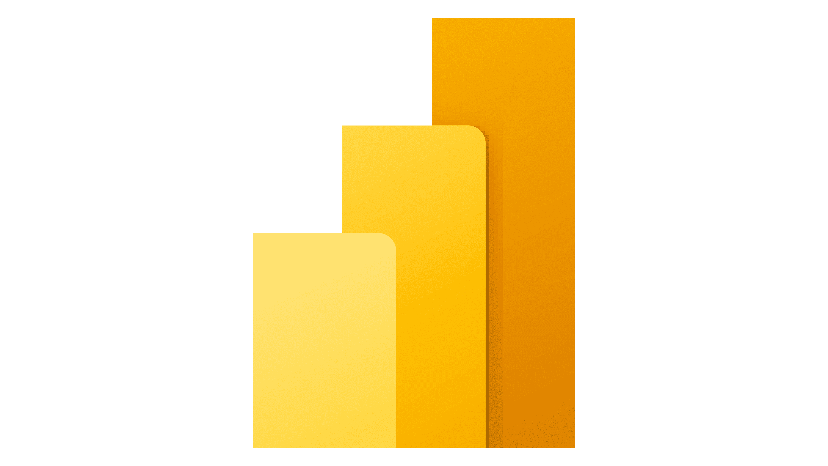
- Power BI
- Git
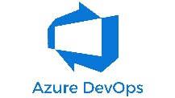
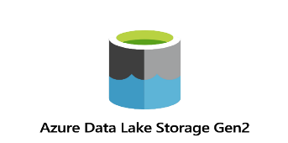
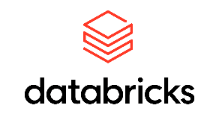
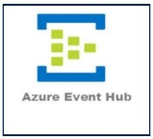
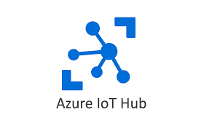

Project Flow:
- Data Sources
  - Simulated IoT devices generating custom weather data (Temperature, Humidity, Wind Speed, Wind Direction, Precipitation, Conditions).
- Data Pipeline
  - Weather data is published to Azure IoT Hub.
  - Azure Event Hubs subscribes and collects the data, placing it into a consumer group queue.
  - Azure Databricks reads the data into a Spark streaming dataframe and writes it to an Azure Data Lake Storage Gen2 container as Delta files.
- Data Lakehouse
  - The Medallion Architecture is used to store data in Bronze, Silver and Gold schema layers.
- Data Visualization
  - Silver layer data is loaded into Power BI.
  - Charts and visuals are used to visualize the data.
- Continuous Integration (CI)
  - Azure DevOps is used for version control.

Technical Documentation

Data Sources
- For this project, a Raspberry Pi simulator was used as a simulated IoT device, and code was written to generate and transmit customized weather data in given ranges below.
  - Temperature : [-5, 32]
  - Humidity : [20, 80]
  - Wind Speed : [5, 25]
  - Wind Direction : ('N', 'E', 'S', 'W', 'NE', 'NW', 'SE', 'SW')
  - Precipitation : [100, 500]
  - Conditions : ('Sunny', 'Cloudy', 'Foggy', 'Clear', 'Partly Cloudy', 'Mostly Sunny', 'Windy', 'Rain')

- Sample Payload:
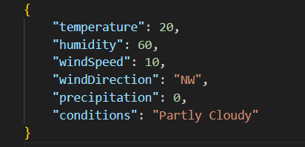

Ex: {
"temperature": 25,
"humidity": 60,
"windSpeed": 15,
"windDirection": "NE",
"precipitation": 300,
"conditions": "Sunny"
}

- Raspberry Pi Simulator: https://azure-samples.github.io/raspberry-pi-web-simulator/
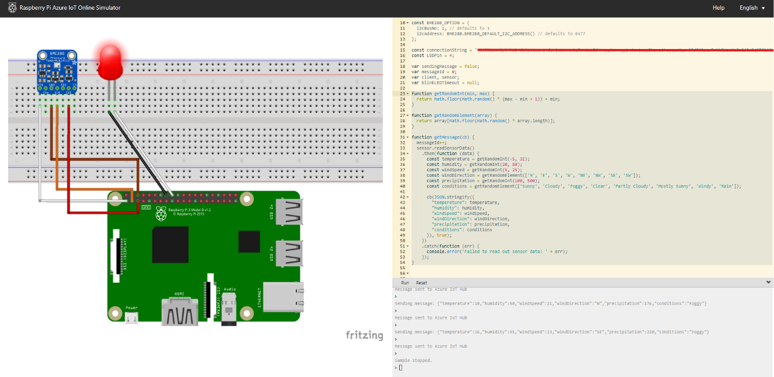

- Code for the sample payload:

Ex:
function getRandomInt(min, max) {
return Math.floor(Math.random() * (max - min + 1)) + min;
}

function getRandomElement(array) {
return array[Math.floor(Math.random() * array.length)];
}

function getMessage(cb) {
messageId++;
sensor.readSensorData()
.then(function (data) {
const temperature = getRandomInt(-5, 32);
const humidity = getRandomInt(20, 80);
const windSpeed = getRandomInt(5, 25);
const windDirection = getRandomElement(['N', 'E', 'S', 'W', 'NE', 'NW', 'SE', 'SW']);
const precipitation = getRandomInt(100, 500);
const conditions = getRandomElement(['Sunny', 'Cloudy', 'Foggy', 'Clear', 'Partly Cloudy', 'Mostly Sunny', 'Windy', 'Rain']);

cb(JSON.stringify({
"temperature": temperature,
"humidity": humidity,
"windSpeed": windSpeed,
"windDirection": windDirection,
"precipitation": precipitation,
"conditions": conditions
}), true);
})
.catch(function (err) {
console.error('Failed to read out sensor data: ' + err);
});
}

Data Ingestion

- Initially using a free-tier Azure account with $200 credit, I built the complete data architecture, including data ingestion, transformation, storage and version control.
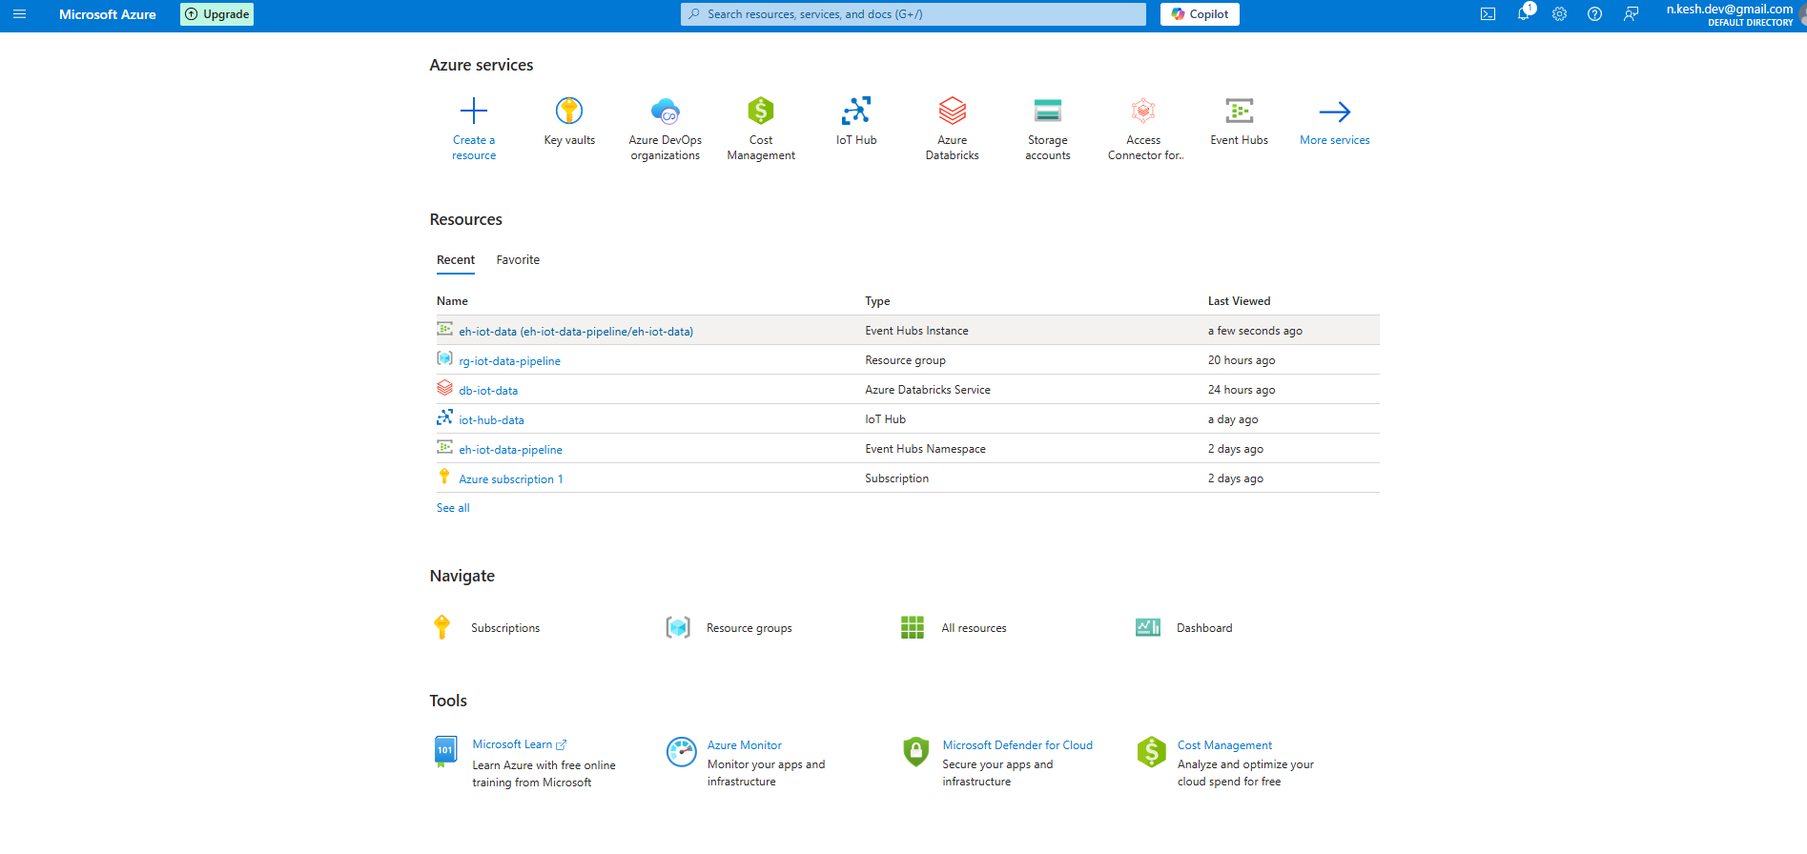

Azure IoT Hub
- Azure IoT Hub was selected as the central communication hub for IoT devices, consolidating data collection into a single point. It provides secure, bidirectional communication between IoT devices and the Azure cloud.

- Compared to traditional message brokers such as MQTT and NATS, Azure IoT Hub offers improved security, scalability, manageability, cost effectiveness and seamless integration with other Azure services.

Steps:
- Create a IoT Hub instance in free tier ( daily message limit 8000)
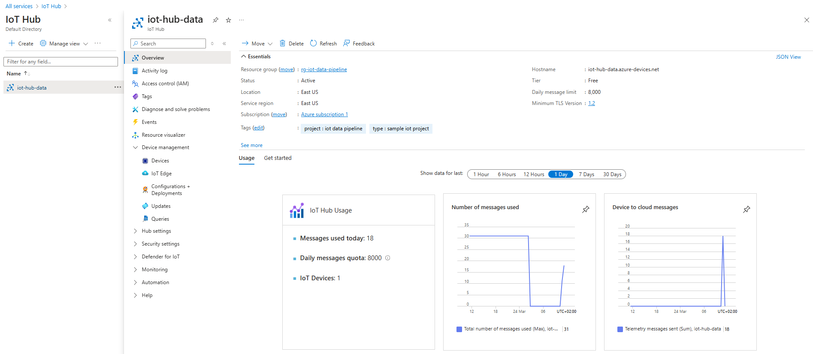

- Add devices on Device Management
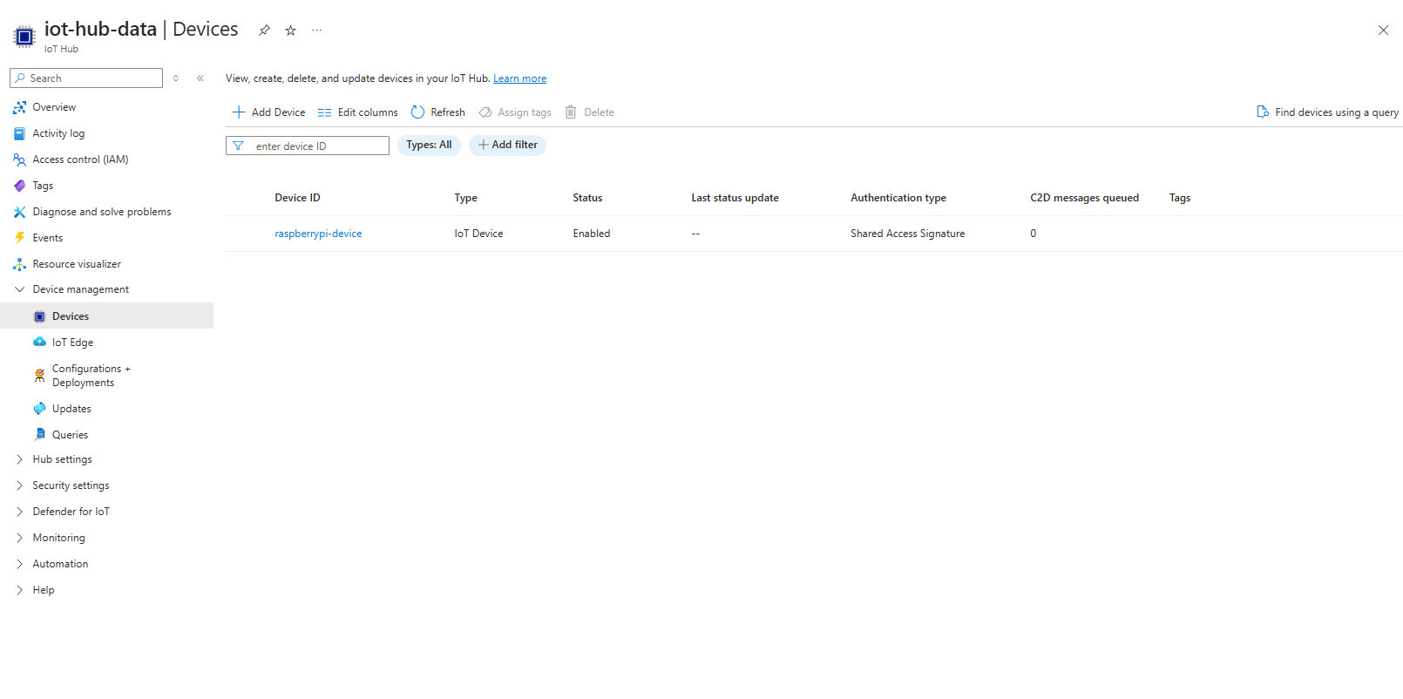

Azure Event Hub
- Azure Event Hubs is a scalable, real-time data streaming service that enables the creation of real-time data ingestion pipelines, allowing consumer groups to analyse data efficiently.
- In this project Event Hubs was implemented as an intermediary between IoT Hub and Azure Databricks.

- Reasons for utilising Event Hub:
  - Event Hub is designed for high volume data streaming, providing a scalable ingestion layer when a large number of IoT devices are connected to IoT Hub.
  - Event Hub enables multiple consumers to read the data concurrently without interference.
  - Event Hub enables the direct storage of data in Azure Data Lakes (not utilised in this scenario) and allows for connectivity with various Azure services.

Steps:
- Create a Event Hub Namespace
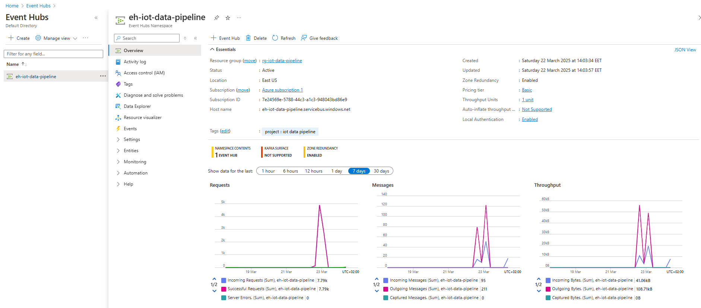

- Create a Event Hub Instance
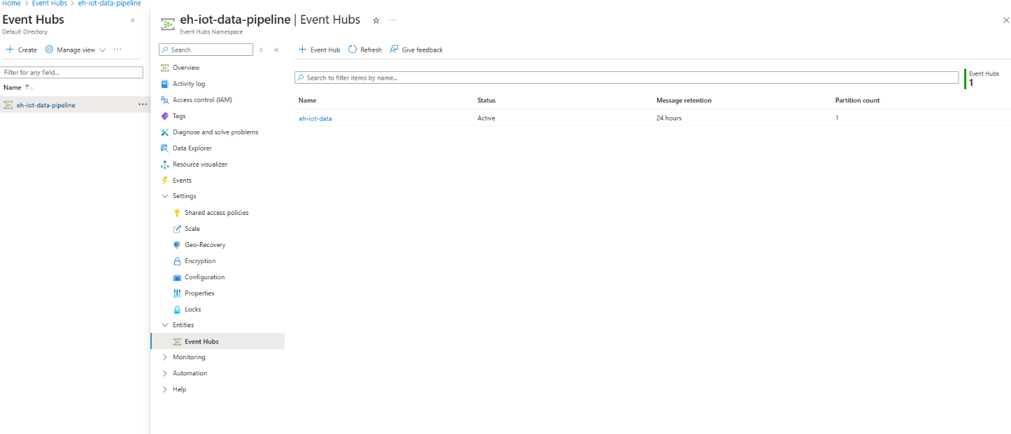

- Create a Message routing from IoT Hub to Event Hub
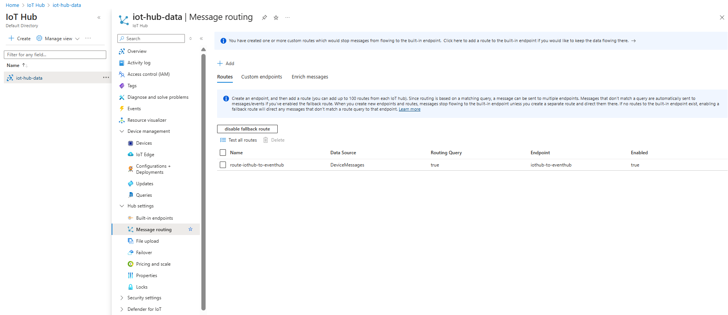

- Create a Shared Policy on Event Hub to enable Listen to the Event hub data from Databricks
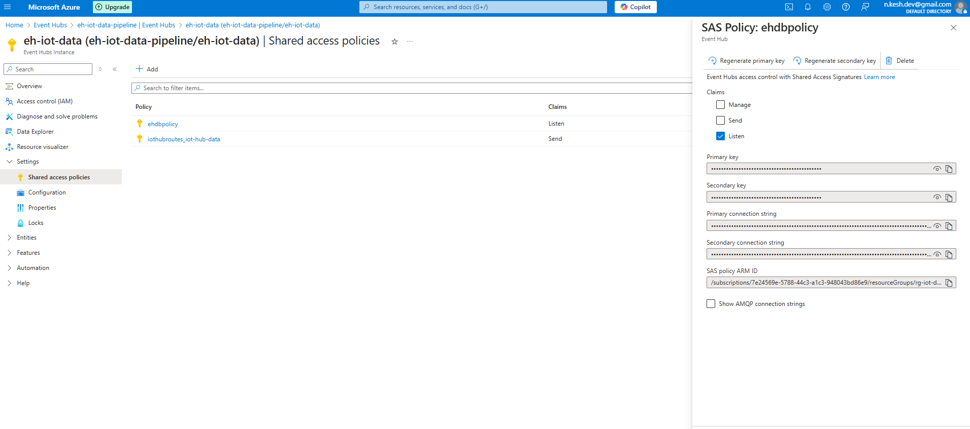

Data Transformation
- Azure Databricks was used for data cleaning, aggregation and transformation. Data ingested from Event Hub was processed within the Databricks environment and stored in Delta Lake. The Medallion Architecture was implemented to organize and store the data facilitating efficient data analytics.

Azure Databricks
- Azure Databricks is a large scale data processing platform built on Apache Spark. It offers robust and efficient data processing capabilities, tools for building data pipelines, a Delta Lake storage layer, access control and data governance through Unity Catalog and an environment for developing machine learning models.

Steps:
- Create a Databricks workspace in Premium tier to enable Unity Catalog
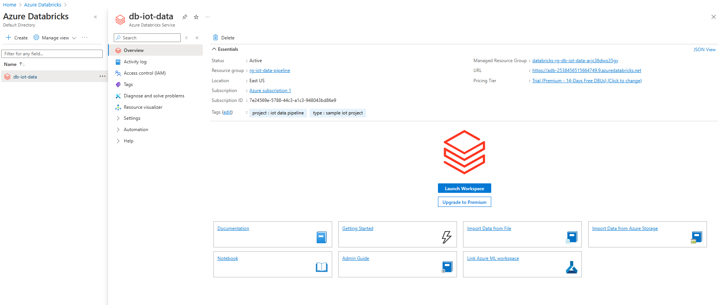

- Launch the databricks workspace and create a single node cluster (To minimize the cost) with general purpose hardware (14GB and 4 cores). Set the termination time as 60 minutes with no activity reduce the cost.
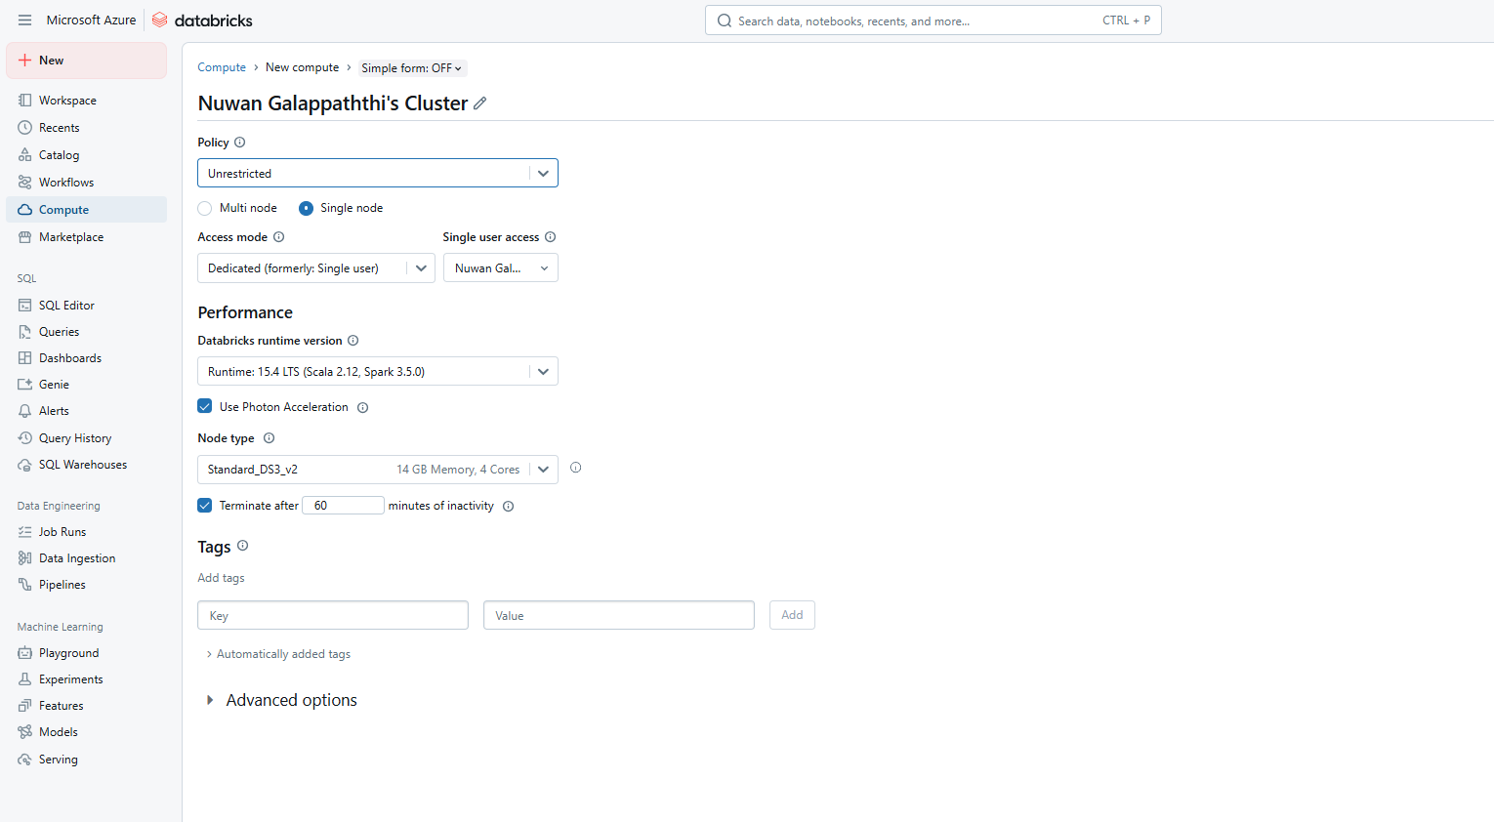

Cluster Summary:
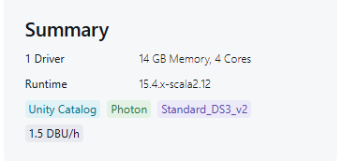

- Set the working library
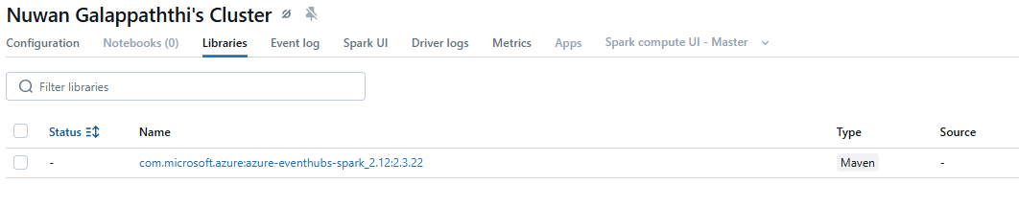

- Start a new notebook and attach it to the cluster
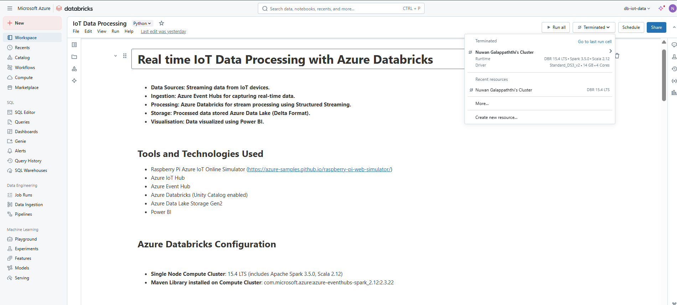

Code explanation

i) Importing Libraries
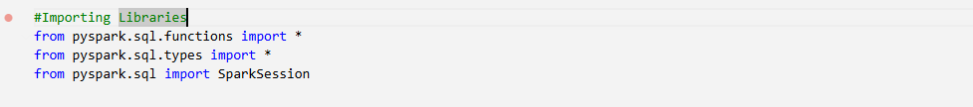

ii) Medallion data storage architecture with bronze, silver and gold schemas within 'db_iot_data_2538456515664749' catalog
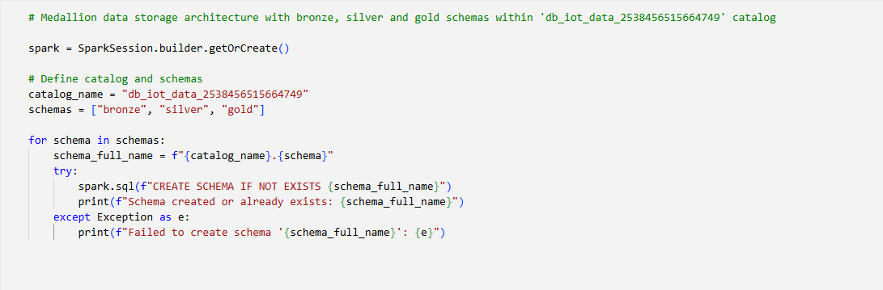

iii) Azure Event Hub configurations
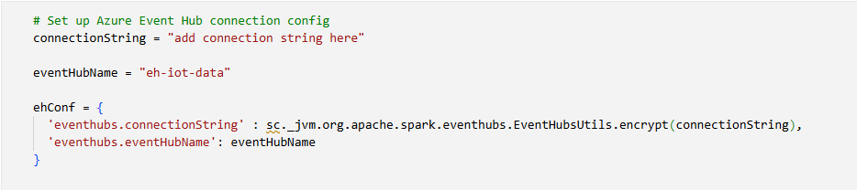

iv) Bronze Layer
- Read from Event Hub and write data to the bronze layer with fault tolerance
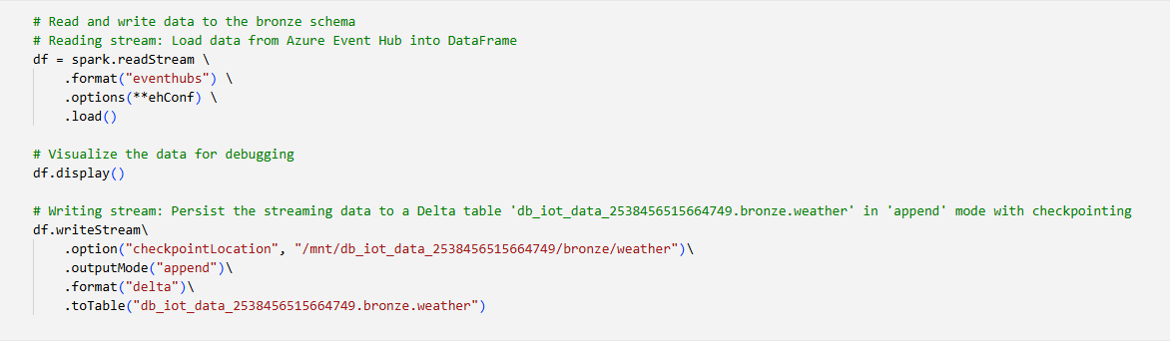

v) Silver Layer
- Defining the schema
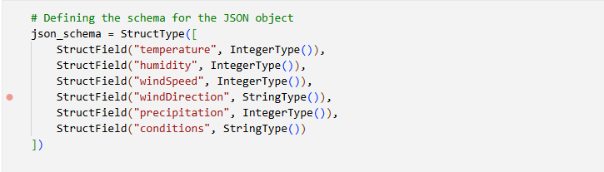

- Read from bronze layer, transform and write back to the silver layer with fault tolerance
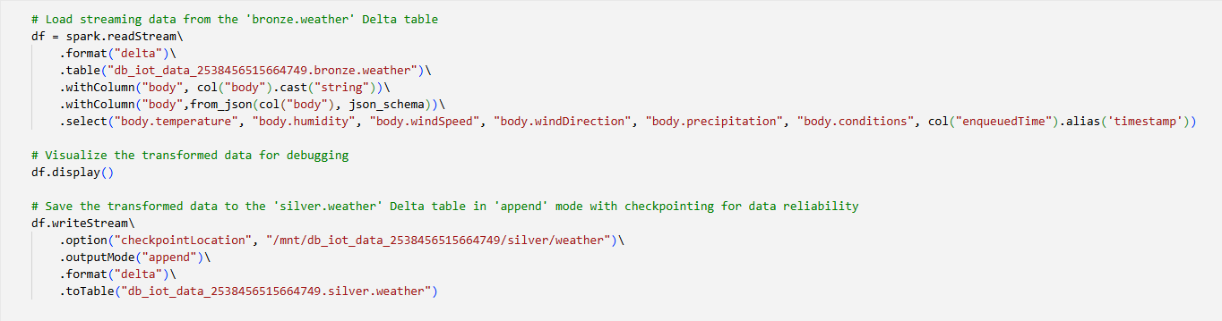

vi) Gold Layer
- Read from silver layer, aggregate and write back to the gold layer with fault tolerance
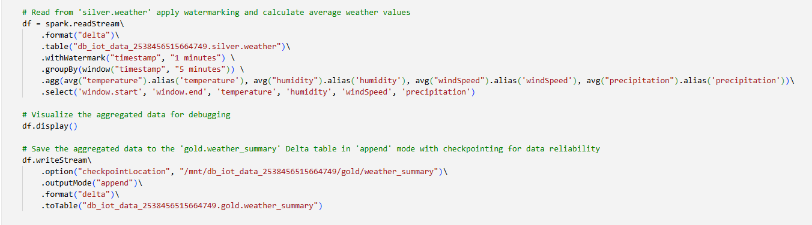

Data Visualization
- Power BI was used for data visualization and report creation. It was directly connected to the Silver layer storage which contains non aggregated data, allowing for detailed insights. If aggregations are required, they can be implemented within Power BI.
Ex:
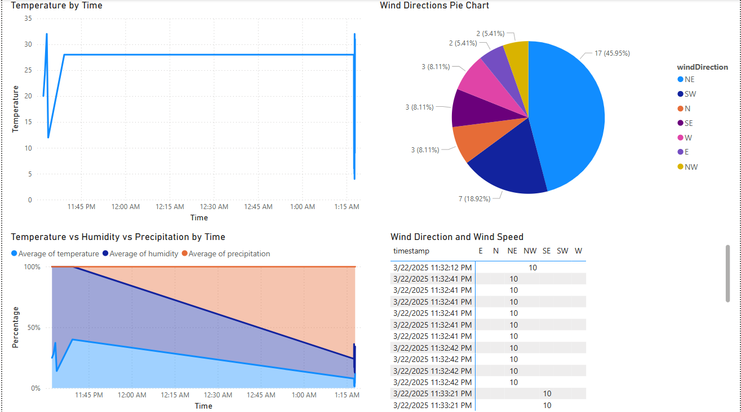

Version Control
- In addition to Azure Databricks versioning, continuous integration (CI) was implemented for the notebooks using Git. Both GitHub and Azure DevOps repositories were utilised for version control.
Steps:
- Create Git folder in Databricks and connect the Github (Select the GitHub as the git provider)
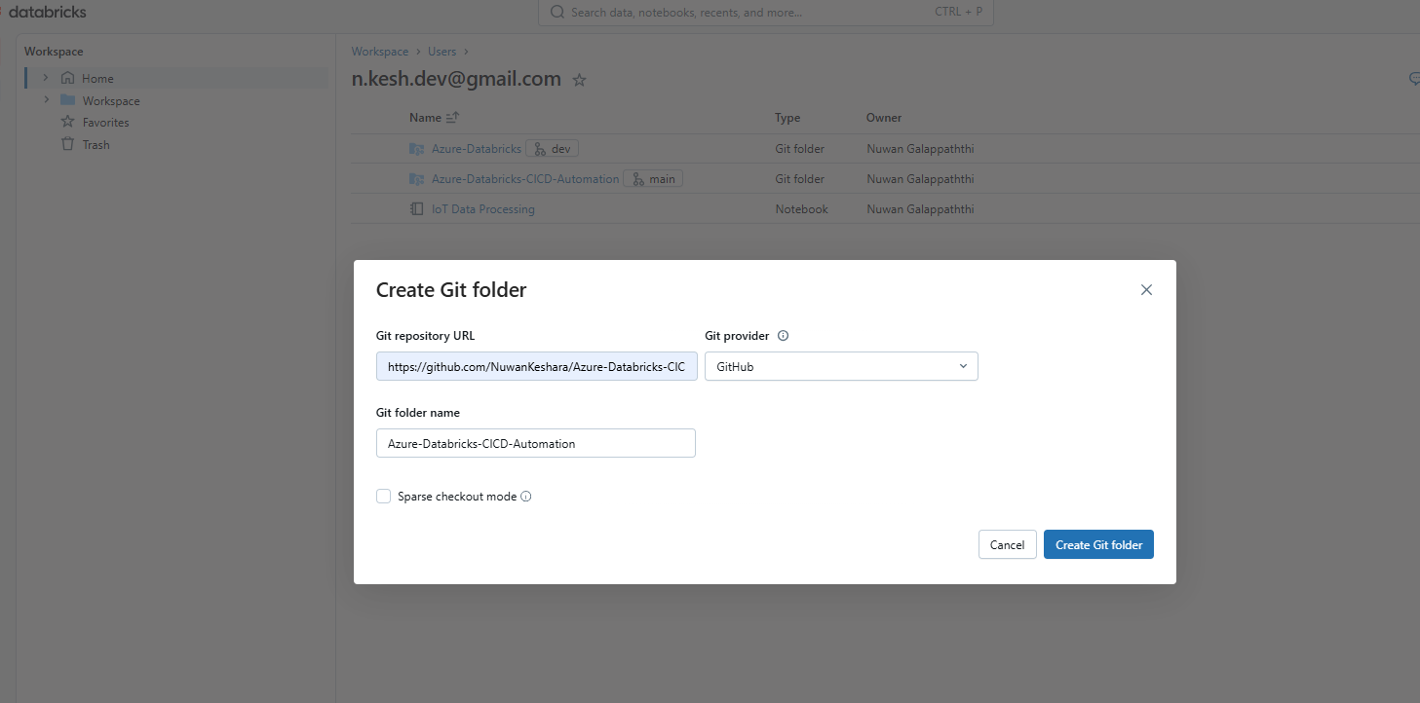

- Generate a personal access token from GitHub and set it in Databricks Linked Accounts section

Azure DevOps
- Same as the above create a git folder and select the git provider as Azure DevOps
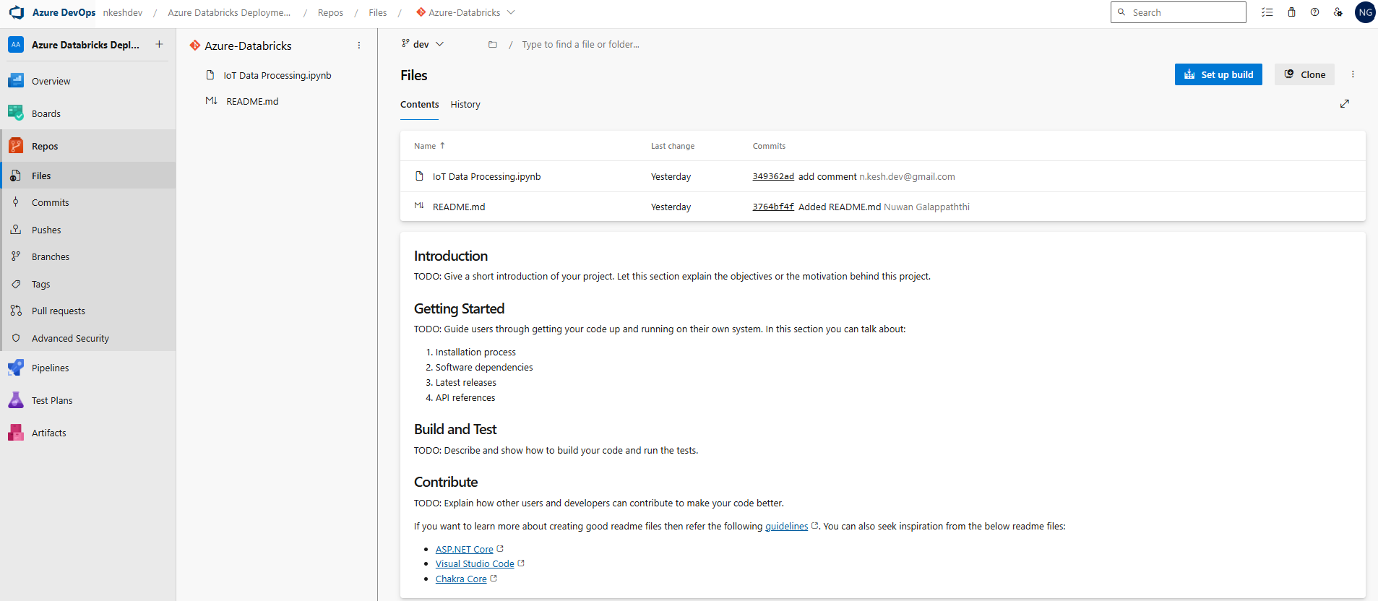

References
- [https://azure-samples.github.io/raspberry-pi-web-simulator/] - Microsoft
- [https://learn.microsoft.com/en-us/azure/iot-hub/iot-hub-compare-event-hubs] - Microsoft
- [https://www.youtube.com/watch?v=2DiC96shSZY] – HarshalkumarJain
- [https://stackoverflow.com/questions/74885334/azure-iot-hub-routing-to-event-hub9 - Stackoverflow (Jan 2022)
- [https://learn.microsoft.com/en-us/azure/databricks/data-governance/unity-catalog/] - Microsoft
- [https://medium.com/@hwangdb/azure-databricks-unity-catalog-part-1-uc-concepts-and-components-2d713f4cb423] - medium (March 2023)
- [https://medium.com/@junshan0/medallion-architecture-what-why-and-how-ce07421ef06f] - medium (Feb 2024)

